Statistics for engineers. Exercise sheet 6: Binomial and Poisson probability laws.

1. A manufacturer wishes to buy 5 machines of Type A. He is told by the supplier that the probability of an individual machine of this type failing within one year of purchase is 0.10.
a) The variable x is defined as the number of machines failing within one year of purchase. Determine the probability that within the first year of purchase
i) no machines fail ; ii) exactly 1 machine fails; (iii) exactly 2 machines fail; (iv) exactly 3 machines fail; (v) exactly 4 machines fail; (vi) exactly 5 machines fail.
b) Draw the histogram showing the probability f(x) against x.
c) What is the probability that no more than 1 machine fails within the first year of purchase?
d) What is the probability that at least 3 machines fail within the first year of purchase?
e) What is the probability that the number of machines failing within 1 year of purchase is greater than 1 and less than 4?
f) The manufacturer discussed in the preceding parts of this example considers a second machine of Type B. He knows that lost production due to machine failures is very costly, hence he stipulates that the probability that none of the new machines break down within the first year of purchase should be 0.95 or more. If he is intending to buy 5 machines of Type B what value of p, the probability that an individual machine fails within 1 year of purchase, should he specify in order to reach the required reliability level?

2. A manufacturer of pet foods believes that sales of the product Purrkins account for 30% of the cat food market. A random group of 10 cat owners was questioned. What is the probability that of that group
(i) none of the group uses Purrkins, ; (ii) at least three owners feed their cat Purrkins,
(iii) at most three of the group feed their cat Purrkins?

3. A manufacturer owns a factory with 8 machines. The probability that an individual machine breaks down in any given month is 0.05.
a) What is the probability that none of these 8 machines break down in a given month?
b) Output is seriously reduced and supplies to customers affected if more than two machines break down in a month. What is the probability of this happening?
c) There is a proposition that the present machines should be scrapped and replaced with 15 new machines. The new machines must meet the reliability requirement that the probability of 1 or more of the 15 machines breaking down in a month should be less than 0.02. If this requirement is to be met what is the maximum permissible value for p, the probability that an individual new machine breaks down in a given month.

4. Demand for a particular item follows a Poisson distribution with an average demand of 5 items per week.
a) What is the probability that in any given week the demand is:
i) 0 items; ii) exactly 1 item ; iii) more than 3 items ; iv) no more than 5 items ?
b) What is the probability that demand will exceed 15 items in any given 4 week period?
c) If the stockist has 15 of these items on the shelf at the start of the month and no replenishment stocks are available what is the probability that she will run out of stock before the end of the month? A month may be considered to be of four weeks duration.

5. A telephone call centre receives an average of 3 incoming calls per minute. What is the probability
a) that no calls arrive in a 1 minute interval,
b) that more than 2 calls arrive in a 1 minute interval,
c) that less than 4 calls arrive in a 5 minute interval,
d) that more than 8 calls arrive in a 5 minute interval?
e) that between 9 and 18 calls inclusive arrive in a 5 minute interval?
f) A study of the way in which telephone queries are answered has shown that it is possible to deal adequately with up to 20 calls in a 5 minute interval with the present procedures. Would you advocate any changes in these procedures?

6. The number of errors, x, made per day by an invoice department follows a Poisson distribution. Monitoring over a long period of time has established that the mean number of errors per day is 2.
a) What is the probability that on any given day:
(i) There are no errors; (ii) there are less than 5 errors; (iii) there are no more than 3 errors?
b) What is the probability that in any given week, where a week consists of 5 working days, the number of errors made will be:
(i) less than 3 ; (ii) more than 3 ; (iii) greater than 10 ; (iv) less than 3 or greater than 10 ?
c) The cost to the firm of correcting each error is £100. What is the probability that in any given week the cost of correcting mistakes will exceed £1,000?

7. The manufacturer wishes to introduce a new dog food product. A survey of 1000 dog owners was carried out. Of the people surveyed 230 said that they would buy the new product. Use this information to put a 95% confidence interval on the proportion of the dog owning public who may be expected to buy the dog food. If it is necessary to capture 25% of the market in order to make it worthwhile launching this new dog food would you go ahead with the launch? Base your answer on the survey results and explain clearly your reasoning.

8. An acceptance/rejection sampling scheme consists of taking a sample of size 20 from a batch of 10,000 items and accepting the batch if the sample contains zero defective items and rejecting the batch if the sample contains more than 2 defective item. If the criteria for either accepting or rejecting the batch are not met a second sample of 10 items is taken. The batch is accepted if this second sample contains zero defective items.
a) If the batch contains 5% defective items use an exact method to determine the probability that:
(i) The batch will be accepted on the evidence of the first sample ; (ii) the batch will be rejected on the evidence of the first sample; (iii) it will be necessary to take a second sample.
b) Use the Poisson approximation to the binomial probability law to determine approximate values for the probabilities specified in part (a) of this example.
c) What is the probability that the batch will be accepted?

9. The probability of an individual player winning in a game of chance is 0.45. If 100 people play the game in the course of one evening what is the probability that:
(i) Exactly 50 players win; (ii) less than 40 players win; (iii) more than 50 players win;
(iv) the number of players winning exceeds the number of players losing.

10. The Maykit Company owns a factory which contains 15 machines of the same type. The machines are all serviced each weekend ready for production to start on the following Monday morning. The time to failure, t, after servicing of a machine is normally distributed with a population mean of 42 hours and a population standard deviation of 1 hour 5 minutes. Any machine which fails remains out of action until the routine service period on the following weekend.
a) If the working week is 40 hours long what is the probability that a given machine will breakdown before the end of the week? What is the probability that a given machine will still be working at the end of the week?
b) What is the probability that none of the 15 machines breaks down within a given week?
c) What is the probability that exactly 1 of the machines fails within the week?
d) What is the probability that at least 1 of the machines fails within the given week?

Solutions
Note: There is often more than one way of obtaining the answer to a problem.

1. Call the number of machines failing within 1 year x where x can take any value in the range 0, 1, 2, ...,5. The variable x follows a Binomial distribution with parameters n=5 and p=0.1.
(a) (i) f(0) = 0.5905 ; (ii) f(1) = 0.3281 ; (iii) f(2) = 0.0729 ; (iv) f(3) = 0.0081 ; (v) f(4) = 0.0005 ; (vi) f(5) = 0.0000.
(c) P[x ≤ 1] = f(0) + f(1) = 0.9184 .
(d) P[x ≥ 3] = f(3) + f(4) + f(5) = 1 - P[x ≤ 2]= 1 - 0.9914 = 0.0086
(e) P[1<x<4] = f(2) + f(3) = P[x£3] - P[x£1] = 0.0811 .

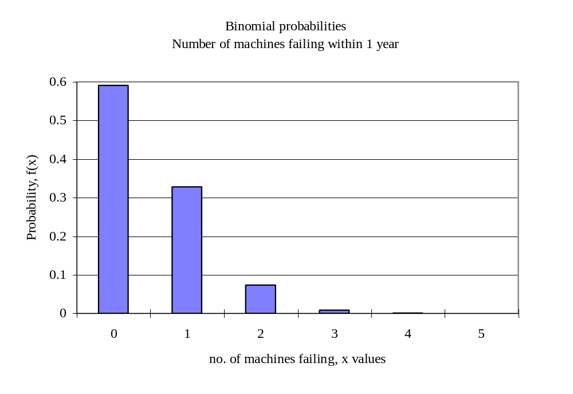
(f) The formula for calculating the probability that x out of 5 machines breaks down within the first year is f(x) = ₅C_{x}p^{x}q^{n-x} , where p is the probability that an individual machine breaks down in the first year. The probability of interest is the probability that x=0, that is f(0) = 1×p⁰×q⁵ , the probability that all 5 machines work for 1 year. This is to satisfy the inequality P[no failures] = f(0) = q⁵ ≥ 0.95 .
Using the equality q⁵ = 0.95 or q = (0.95)^{1/5} giving q = 0.9898 and p=0.0102. Check the answer by calculating (0.9898)⁵. The required level of reliability will be reached with p ≤ 0.0102.

2. There are n=10 people with a probability p=0.30 that an individual uses the food. Call the number of owners choosing Purrkins x where x can take any value in the range 0, 1, 2, ...,10. Use the binomial probability law with parameters p = 0.3 and n = 10..
(i) f(0) = 0.0282 ; (ii) P[x ≥ 3] = 1 - P[x ≤ 2] = 1 - 0.3828 = 0.6172 ; (iii) P[x ≤ 3] = 0.6496.

3. Call the number of machines failing within a month x where x can take any value in the range 0, 1, 2, ...,8. The binomial probability law applies with n=8 machines, each machine has a probability p = 0.05 of failing within a month and q =1-0.05=0.95 of not failing within a month.
a) P[x=0] = f(0) = 0.6634 .
b) P[x > 2] = f(3) + f(4) + ... + f(8) = 1 - P[x ≤ 2] = 0.0058 .
c) There are to be n = 15 machines, with a probability p that machine breaks down within a given month. The requirement is that P[x > 0] ≤ 0.02 , or P[x=0] ≥ 0.98 . Using the same method as Example 1 with n=15, and taking the equality gives q¹⁵ = 0.98 and q = 0.9987 to 4 decimal places. In order for the probability of no breakdowns within a given month to be 0.98 or more the probability that an individual machine breaks down within a given month must be 0.0013 or less.

4. Call the number items demanded in a week x. In theory x can take any value in the range 0, 1, 2, ...,∞. The Poisson probability law applies with the average per week μ=5 items.
a) (i) f(0) = 0.0067 ;
(ii) f(1) = 0.0337 ;
(iii) P[x>3] = f(4) + f(5) + .... = 1 - P[x ≤ 3] = 1 - 0.2650 = 0.7350 . ;
(iv) P[x ≤ 5] = 0.6160 .

b) The unit of time is now 4 weeks with an average demand of μ = 4×5 = 20 items per 4 weeks.
P[x > 15]=1 - P[x ≤ 15] = 1 - 0.1565 = 0.8435.
c) This is the probability that the demand will exceed supply which is the 15 items on the shelf at the start of the 4 week period, that is, P[x > 15] = 0.8435.

5. Call the number of incoming call x where x can take any value in the range 0, 1, 2, ...,∞.
A Poisson probability law applies with an average of μ = 3 calls per minute.
a) P[x = 0] = f(0) = 0.0498 .
b) P[x > 2] = 1 - P[x ≤ 2] = 1 - 0.4232 = 0.5768 .
c) The unit of time is 5 minutes. There are μ = 5×3 = 15 calls on average per 5 minute period.
P[x < 4] = P[x ≤ 3] = 0.0002 .
d) P[x > 8] = 1 - P[x ≤ 8] = 1 - 0.0374 = 0.9626 .
e) P[9 ≤ x ≤ 18] = P[x ≤ 18] - P[x ≤ 8] = 0.8195 - 0.0374 = 0.7821 .
f) Changes will only be justified if there is high probability that the call centre cannot cope with the incoming calls, that is, if P[x > 20 calls per 5 minutes] is large. P[x > 20] = 0.083 . It is expected that there will be problems with the centre in approximately 8% of 5 minute intervals . If 8% is judged to be too high a probability then changes in the procedure should be investigated.

6. The average is μ = 2 errors per day. Call the number of errors per day x where x can take any value in the range 0, 1, 2, ...,∞.
a) (i) f(0) = 0.1353 ; (ii) P[x < 5] = P[x ≤ 4] = 0.9473 ; (iii) P[x ≤ 3] = 0.8571 .
b) The average is now μ =5×2=10 errors per 5 days.
(i) P[x<3] = P[x ≤ 2] = 0.0028 ; (ii) P[x > 3] = 1 - P[x ≤ 3] = 0.9897 ;
(iii) P[x > 10] = 1 - P[x ≤ 10] = 1 - 0.5830 = 0.4170 ;
(iv) P[x ≤ 2] + P[x > 10] = 0.0028 + 0.4170 = 0.4198
c) If there are more than 10 errors in a week the cost will exceed £1000. P[cost>£1,000] = 0.4170 .

7. The proportion of dog owners buying the food is p. This is estimated as = 230/1000 = 0.23 . The proportion not buying the food is = 1 - = 0.77 .
The standard error of is √(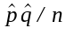) estimated as √(0.23×0.77/1000) = 0.0133 .
95% confidence limits on p are 0.23 ± 1.96 × 0.0133 = 0.23 ± 0.0261 .
The estimate of the true proportion of the population buying the food is 0.23 or 23%. There is 95% confidence that this estimate is accurate to ±0.0261 or ±2.6% . The lower limit is 20.4% and the upper limit is 25.6% . The proportion of 25% is only just within the 95% confidence interval. It would be risky to launch this product.
8. The sample size is n=20. The batch size is large hence the proportion of defective will be virtually unchanged by taking a sample of size 20., i.e. p is constant. The binomial probability law applies.
a) The proportion defective is small, p=0.05 . The sample size is fairly large, if great accuracy is not required the Poisson approximation to the binomial probability law may be used with μ = np = 20 × 0.05 = 1.0 .
Method I: Using the exact binomial probabilities:
(i) P[batch is accepted on the first sample]=f(0)=0.3585 .
(ii) P[batch is rejected on the first sample]=P[x>2]=0.0755.
(iii) P[second sample is taken]=f(1)+f(2) = 1 -P[x>2]-P[x=0]
= 1 - 0.0755 - 0.3585 = 0.5660.

Method II: Using the approximate Poisson probabilities:
(i) P[batch is accepted on the first sample]=f(0)=0.3679 .
(ii) P[batch is rejected on the first sample]=P[x>2]=0.0803.
(iii) P[second sample is taken]=f(1) + f(2) = 1 - P[x > 2] - P[x = 0]
= 1 - 0.0803 - 0.3679 = 0.5518.
c) The batch may be accepted after the first sample or after the second sample. The figures for the binomial probability law are given below:
P[accept after 1st sample] = 0.3585.
P[accept after 2nd sample] is the probability that a second sample is needed and that the second sample contains zero defective items.
Assuming that the second sample is independent of the first the probability of zero defectives in the second sample is
P[x = 0] = 0.5987 , using n = 10 and p = 0.05.
P[accept batch] = P[accept at 1st sample] + P[(second sample is taken) and (accept at 2nd sample)]
Using the axioms of probability for independent events
P[(need a 2nd sample) and (accept at 2nd sample)]
= P[need a 2nd sample] × P[accept at 2nd sample]
= 0.5660´0.5987 = 0.3389 .
P[accept batch] = 0.3585 + 0.3389 = 0.6974 .
The probability that a batch will be accepted is 0.6974, or, it is expected that 69.74% of batches will be accepted under this sampling plan.

9. Call the number of players who win x. Then x obeys a binomial probability law with n=100 , p=0.45 . The value of n is large and p is close to 0.5 with npq=100 × 0.45 × 0.55 = 24.75 which is greater than 3, hence the normal approximation to the binomial probability law may be used with mean μ = np = 45 and standard deviation σ = √npq = 4.9749 . Remember that x is a discrete variable, the continuity correction of 0.5 must be used.
(i) P[exactly 50 players win] = P[50-0.5£x<50+0.5]
= P[x£50.5] - P[x£49.5]
= 0.8655 - 0.8172 = 0.0483 .
(ii) P[less than 40 win] = P[x£39.5] = 0.1345 .
(iii) P[more than 50 win] = P[x>50.5] = 0.1345 .
(iv) P[more win than lose] = P[more than 50 win] = 0.1345 .

10 a) Use the normal distribution to determine the value of p as P[time < 40]. The population mean for the variable time is μ_{t} = 42 hours, the standard deviation is σ_{t}=1.0833 hours.
P[t<40] = P[u<(40-42)/1.0833] = 0.0324 .
Hence the probability that a machine breaks down in any given week is p=0.0324 . The probability that a machine is still working at the end of the week is q=0.9676.
b) Call the number of machines breaking down in a specific week x. Use the binomial probability law with n=15 and p=0.0324.
P[x = 0] = f(0) = 0.6102 .
The probability that no machines break down in a specific week is 0.6102 .
c) P[x = 1] = f(1) = 0.3065 .
The probability that exactly 1 machine break down occurs in a specific week is 0.3065.
d) P[x ≥ 1] = 1 - P[x = 0] = 0.3898 .
The probability that there is one or more machine break downs in a specific week is 0.3898.
Note: This probability includes the possibility for any number equal to or greater than 1.

